Anonymous Dislike
Users' Reaction to Anonymous Peer Reviews in Social Network

Pranshu Oneil Kalvani
Institute of Software Research
Carnegie Mellon University
Pittsburgh, USA
pok@andrew.cmu.edu

Chao Pan
Institute of Software Research
Carnegie Mellon University
Pittsburgh, USA
chaop@andrew.cmu.edu

Abstract— Over the last decade social networks have made a huge impact on the activities of a large part of the population. The purpose of this paper is to show that the lack of an unbiased feedback provided to users, results in embarrassing situations, among other abnormal behavior. We studied the level of this problem by conducting two surveys of Facebook users. The results of these surveys have led to the implementation of an anonymous commenting system. The tool and its efficacy is then tested in two following users’ studies.
Index Terms— privacy; anonymity; peer reviews; social networks; Facebook; nudging

Introduction
One of the most remarkable abilities of humans is that of talking to one another. With the advent of social networking there has been a paradigm shift in the way we socialize [1]. The rapid change in the way we converse has led to our present state, which is lacking in well-defined social etiquettes and nuances that we are used to in normal conversation. The lack of norms governing conversation online to a vast majority of online social misdemeanors [18].
People are known to post things on social networks that they sometimes regret subsequently [2, 3]. However, more often than not, they do not realize if they have posted something offensive to someone or inappropriate for a larger audience. This is due to the lack of a robust feedback mechanism [4]. Prior studies have shown that most of the awareness of posts online is based on a users’ self-realization (58% for Twitter users) [3]. This is a huge additional burden that a user must take on to be active on social media sites, especially as inappropriate posting can lead to repercussions ranging from regret to job loss [2].
The purpose of providing feedback is to help people realize the error of their ways. By receiving an external feedback, overdependence on self-realization should diminish significantly. This should help them take necessary steps in correcting themselves, and the presence of external agents in turn should make them more conscious about the decisions they take with their future posts as well.
We started our study by conducting a survey of social network users, targeting Facebook users to see if they noticed any inappropriate behavior online, and their reasoning behind responding or not, to this behavior. We found that all frequent users have seen inappropriate behavior online, and people who do not see any appropriate posts online are either infrequent users or have fewer friends on Facebook. When asked if the people who saw inappropriate comments online responded to any of these comments, we found that a little over a quarter (27%) of these users responded.
When we proposed a tool to anonymously comment on Facebook posts we found that the percentage of users willing to respond jumped up to a little under two-thirds (65%). These results were promising in the argument for anonymity. Details of these results can be seen in the results section of this paper. Based on these results we felt it would be useful to study if people would benefit from getting feedback.
This led us to our second survey which essentially found out that most people show bounded awareness about their inappropriate posts. Most of the identification of the independent comments is a result of self-awareness. Only a fraction of users received any feedback from their Facebook friends. But when asked if feedback on posts were beneficial, a sizeable portion (77%) agreed that it would have helped. There are more details for these results present in the results section.
Based on these results we created an online system that will allow users to anonymously comment on Facebook. This tool is a Google Chrome extension and allows users of this system to provide feedback without revealing their identity. We faced many challenges in building this tool as Facebook kept updating its Document Object Model (DOM) causing our system to crash on a regular basis. This led to regular loss of data as well.
Our work takes a first step in examining if people will amend the error of their ways if they are told to do so by their peers on social networking sites. While this still has a lot of possible future work, we believe this is still a critical step in the right direction to help improve user behavior on online social networks.
In the next section we present background and related works. We then introduce our study methodology and then present their results. Based on these results we go on to describe the anonymity tool we have developed. To test the system developed, we illustrate our two studies to show the system. We conclude with a summary of our findings and needed future work and the implication of our tool.

Background and Related Work
Although our work is novel in the study of anonymity on social networks, it is firmly grounded due a lot of prior work in the study of the online behavior of social network users, as well as literature from many other fields.
This project aims to provide nudges to users’ posts based on peer review. Basically, if someone feels that something on a social networking site might be offensive/inappropriate/etc. they can anonymously provide their opinion without having to worry too much about being directly associated with the person posting. As the famous Oscar Wilde quote goes "Man is least himself when he talks in his own person. Give him a mask, and he will tell you the truth."
We will discuss literature that we have found relevant to our study in the following sections:

- Online regrets / inappropriate behavior:
Prior works have shown that people feel regret about posting inappropriate comments. Wang et al [2] showed that users tend to regret posts made about topics relating to sensitive information. These comments involve a wide range of areas including alcohol, sex, politics, religion, relationships, profanity and negative comments, lies, secrets and regrets regarding their jobs or bosses. While their work focused on Facebook, a similar situation can be seen on Twitter. Sleeper et al [3] conducted a more extensive research of Twitter users. As the comments on Twitter are broadcasted to a larger audience, they compare the conversational perspective with the regret in Twitter and find that this problem is more serious than the problem on Facebook.
A Pew Internet survey [6] has shown that 9% of Facebook users at some point took a break from Facebook because there was too much drama, gossip, negativity, conflict, or For various similar reasons. This goes to show that not agreeing with content online is clearly a problem that can cause users to stop using a social network. Or, as another Pew Internet survey [30] has shown, 63% of social network users have removed people from their "friends list."

- Need for feedback:
The lack of instantaneously available feedback in online communication is a major cause of most regrets. The cues that we get from regular conversation are not present in online communication. The ability of knowing your target audience as you communicate is one area that is difficult to assess. With complex privacy settings in online social networks, the issue of unintended audiences is a fairly common one. Getting visual/auditory cues, if what was being said was understood in the correct context/intention. This is particularly important when it comes to sarcasm or jokes. These changes result in a behavior called online disinhibition [29].
As we mentioned before, online users rely a lot on self-censorship and self-realization which is a huge additional burden that a user must take on to be active on social media sites [3]. By getting external feedback, this burden should be lifted due to the availability of comments.
Visibility/retention of the post for a long duration is another important distinguishing fact. Normal spoken conversation is ephemeral; posts on Facebook will remain visible for a long time. Once on the internet, they may come back to haunt you later [29].
Facebook users seem to have a "commission bias" in which even if posts have negative outcomes, which are immediate, the impulsiveness of sharing or posting trounces the negative outcome, leading to regrets [2]. We hope to overcome this bias by providing users with feedback helping them to be more aware of their posts.
Communication apprehension which might prevent users from providing feedback should be overcome by anonymity [30].

- Nudging implementations:
Nudges are paternalistic interventions that suggest to individuals to follow certain types of behavior [16]. Prior nudges include timers that allow users to rethink about their posts before posting, allowing users to see random selection of the audience of their post, and machine learning algorithms that parse through a post to study its content. It has been shown that people find it intrusive if even computer algorithms analyze their posts [4], as these nudge mechanisms are thought to be judgmental. However, privacy nudging has shown significant improvement in the online behavior of users [4].
An important distinction between the work by Wang et al [2] and ours is that most of the work done in the former nudges users' before they make their posts. Our project aims to study the effect of nudging users after they make their posts. Another distinction is that Wang et al implemented sentiment nudging that tries to figure out the sentiment of the post using natural language processing techniques. These techniques were found to provide absurd results as well as feelings of intrusion on the part of the posters.
To overcome the above mentioned shortcomings in the sentiment nudging proposed by Wang et al, we believe that allowing users, who can already see a post, could provide anonymous nudges, resulting in a definite advantage. Our survey shows that people are likely to respond to these feedbacks, hence providing a working nudging implementation system.

- Internet anonymity:
Anonymity on the internet has many arguments for and against it. It has been shown that people do want anonymity and also the strategies used by them may not be as effective as they might believe. To keep different social circles separate, people have been found to keep multiple social network profiles, and use fictitious profiles to remain anonymous [17].
It has been suggested that anonymity in social networks may lead to less social accountability [18]. A study by Kang et al [17] showed that half the users of anonymous systems used it for illegal or malicious activities. Yet the same study showed that anonymity was necessary in providing unbiased critical evaluations of original content.
We can see that there are reasons both for and against anonymity online. As our study is more focused on trying to critique posts that a person may find inappropriate, we argue that anonymity is essential.

- Users’ compliance:
Literature shows that authoritative tones are more likely to induce compliance in anonymous situations [13, 14]. Another important criterion in enhancing compliance is the availability of strengths-based feedback instead of only negative commentary.
We included this in our related works as it was found in our study that given anonymity, people were more likely to post inappropriate comments themselves. This was an argument for limiting users' comments to one’s that were found to inappropriate by a large audience. The inappropriate posts were identified based on the findings of the Wang et al's paper based on user regrets [2], these findings were validated in our surveys as well. Our surveys and studies have made us add and subtract different inappropriate post types from this list.
Maximizing compliance of users based on feedback received is one of the core functions of our system. However, due to time constraints we did not manage to fully test the implementation of the findings.

- Facebook features:
Facebook is a popular social networking site. It allows users' to post comments (status updates) or media either on their own Timeline or Timeline belonging to their Facebook friends. The timeline are visible to certain groups of people depending on a user’s settings.
An important feature called the News Feed is a part of Facebook that our system is targeting; even though our system originally used to work on the Timeline as well, certain changes have made this feature non-operational. The News Feed brings together all stories (i.e. status updates, likes, links, content, application activity) to one place. When users log into their own account, they land onto this page.
Facebook has additional features that allow users to select their target audience for posts such as private lists, groups, and private pages [20]. However, it has been found that most of these features are too complicated or time intensive for regular users [4].
An important feature in any software setting that affects privacy is the use of defaults [19]. The defaults are not very privacy sensitive as they are generally set to an audience being the general public instead of just friends or friends of friends. Making posts more targeted should help in handing regrettable posts, as prior work in nudging has shown that users being made aware of their audience makes them more conscious about their posts [2].

- Anonymous Peer Reviews:
Peer reviews have been studied for a long time, not in social media but in academia [34]. Anonymity in these systems is provided to the author, not the critic. Our study tries to provide anonymity to the critics not the authors. People may reflect on their own thoughts based on anonymous feedback. Even though anonymous comment systems have been discussed for a long time [18], it is unclear whether they good or bad tools overall. It is still very much an area that is based on qualitative analysis of the effects on users of the system.
The anonymous effect of peer review, in the evaluation of work by one or more people of similar competence to the producers of the work, is discussed in Madden’s work [10]. In our system we can think of the creator of a post as the producer of the work, and that person’s Facebook friends as the people of similar competence.
An example of these anonymous peer reviews can be seen in Kagan et al [11] where evaluating nursing managers anonymously is proved effective in improving managerial performance. In fact, the added anonymity in peer reviews is shown to be more effective than identified reviews in a study by Lu and Bol [12].

Methodology
Our study focused on the perceived inappropriate behavior on social networking sites, and the reactions of various users using those sites.
The social networking site we took for our study was Facebook. The reason for doing this includes, among other things, its popularity [7]. With over a billion users, Facebook is currently the largest social networking site. It is also a networking site that doesn't allow anonymity. With the hopes of getting larger target audiences in the right environment for our study we concluded that Facebook is the best option for us.
We started the study by conducting a survey to see if our proposed problem of inappropriateness online existed and what people's reactions were, both without and with anonymity. We then checked if our proposed solution was useful in order to proceed with actual implementation of the system. We start by reporting on two surveys in this paper.

- Surveys:
The purpose of our first survey (hereafter called 'survey 1') was to get an understanding of Facebook users’ views on the types of posts they view. We were also interested in their reactions and reasoning behind the lack of reaction to these posts.
We then asked about the types of responses they would make if they were provided any anonymous commenting system. Users’ reactions after receiving such comments were also studied.
Based on the findings from survey 1 we created a second survey (hereafter called 'survey 2') to better understand the usefulness of our proposed solution to the behavior of users. That is, if anyone valued any comments they received or just discounted them altogether.
We include all survey questions in Appendix A.
Our survey was conducted as follows:
  - Procedure
We hosted our surveys on KwikSurveys. We then recruited users using Amazon's Mechanical Turk (MTurk). Our surveys were posted as a “task” on MTurk one at a time, each for a duration of 3 weeks.
Workers on MTurk have a unique ID; each MTurk ID was allowed to answer only once. The qualification criterion was that the workers had to be Facebook users. Of a total of 52 results in survey 1 we had to dismiss 3 users as they were not Facebook users. Similarly in survey 2 we had to dismiss 2 results out of the 43 that we collected.
We paid each participant $0.30 for survey 1. It worked out to an average of $3.53 per hour for survey 1. Each survey took an average of a little over 5 minutes.
We paid each participant $0.30 for survey 2. It worked out to an average of $4.51 per hour for survey 2 as each survey took an average of a little under 4 minutes.

  - Limitations
This study was limited in the amount of surveys conducted due to time and financial constraints. We do not believe the study to be a true distribution of actual users as the population of our data is small n=49 for survey 1, and n=41 for survey 2.
Though not a true subset there were interesting and useful results that did mimic prior findings from other studies regarding regrets. This goes to show our results though not perfect were close enough to make basic assumptions.
The exact limitations can be seen in the analysis subsection within the results section.

  - Analysis
Basic compilation of data was initially performed after gathering the information to ensure data quality. This data was further transformed into visualizations to view the data.
We further analyzed participants’ responses in the hope of finding interesting insights into the data. To do this we added all the data gathered into a SQL database. On this SQL database we performed associative rule mining to get interesting results we might have missed when we just used data visualization. We set a threshold for support greater than 0.1. This means if the pattern was observed a minimum of 10% of the total data set it had a support greater than 0.1 [27].
Though finding patterns may be interesting to us in itself, they mean nothing. To find possible explanations for the findings we turned to literature from the behavioral sciences. Some of these findings along with their possible explanations are shown in the results section.

- System Implementation:
Based on the outcome of the surveys we have created an anonymous commenting system as a Google Chrome extension for Facebook users. The details of our system can be found in the System section of this paper..
We started working on our system concurrently with survey 1. Actual feature implementation was based on the findings from our surveys. Our plans to complete implementation early so as to get a longer duration for actual user studies were soon foiled with the barrage of changes made by Facebook.
Each of these changes caused a significant inconvenience to both our schedule and workload, not to mention consistent loss in usable data.

- Semi-structured Usability Study:
After the completion of our system implementation we conducted a think aloud study to get a better understanding about the usability of our system. The feedback we received from this study resulted in minor user interface (UI) fixes to our system. We did however implement a rating system and add it to the system as most of the users felt it would help measure their feeling about a post in the sense of interestingness.
We did continue to have problems with the UI even after our study as Facebook kept making changes to their page.
We initially asked our friends and colleagues (n=5) to test our system out and provide feedback. After making a few changes we then tried our system in the real world. The recruitment for this study involved asking people on our university campus to participate for a small reward of a cookie. Each user took on average of 10 minutes to complete the tasks we assigned to them. We had 10 participants in our study.
The procedure of the study and list of tasks is included in Appendix B. We followed the task list and based our sub-questions on the situation. If the users mentioned a problem they were having for e.g. we found 4 users wanting to point out comments that they found annoying. Based on this feedback we suggested a rating system to all the study subjects. We had mixed reactions to the utility of such a system.
These interviews were recorded by making notes of the suggestions, problems, and ideas put forth by the participants.

- User Study:
The purpose of this study was to check if users would take any action based on feedback they received on our system. We needed a stringent recruitment procedure, as short of getting a large group of users to adopt our system in a short duration, there was great difficulty in actually finding users who have posted inappropriate comments.
With constant updates to our system to keep it functioning on Facebook wide spread adoption was not feasible as it would involve trying to keep all users up to date with the latest version, and also the constant updates meant we would lose data on a regular basis.
To get only users who have inappropriate comments on their feeds, we had to recruit people by asking them to become friends with a profile on Facebook we had created for the purpose of this study. Then these recruits were manually scrutinized for inappropriate posts. This did not lead to a large number of users in our final study.
Out of the 10 recruits that applied for the study, only 3 had posted anything inappropriate. Of these 3 participants we managed only 2 interviews. This is a mere fraction of the total applicants. We also had decided not to recruit people we knew for the interview as this might have caused a bias in their answers. To avoid this self-serving bias we did not allow our friends that who wanted to participate in the study even if they were eligible [23].
We recruited users by posting flyers all around our University campus. These flyers offered a $10 Amazon gift card to users who were found eligible for the study after adding our study’s Facebook profile and then completing our interview. The first interview lasted 50 minutes and the second interview lasted 45 minutes.
The purpose of the interview was to get a better understanding of the feeling of the participants on receiving feedback. In a perfect world we would have liked if we could have recruited a friend of the participant to identify inappropriate posts, but in this case we told participants that a black box identified certain posts as inappropriate and made suggestions. In actuality the black box was the authors of this paper going through participants’ profiles with a fine tooth comb trying to find inappropriate comments.
With the final version of our system ready in time for this interview we asked for feedback on our system. This system incorporated changes we felt were needed based on the feedback we received. This part of the interview was performed similar to our usability study.

Results
Before This section gives details about all the data that was collected and provides an explanation wherever possible for these results. The details of our analysis are also elucidated.

- Survey 1:
  - Demographics:
This survey had 49 participants after removing data that did not meet the desired quality standards. The quality of data was determined on how much time it took to fill out the survey, if it was found to be less than 2 minutes we discarded the data.
We had 26 male participants and 23 female participants. Participants’ ages ranged between 20 and 76 years. A distribution of the age can be seen in fig. 1. We believe this to be skewed towards the younger users. Facebook user demographics [21] show that Facebook has more middle aged users than younger users. We assume this skew is due to the rather small payment for completing the survey; this might have driven away older MTurk workers.
The frequency of their Facebook usage was well distributed. The distribution can be seen in fig. 2.
Here the definitions for each term of Facebook usage was:
- Frequently is usage more than once a day,
- Often is usage once a day,
- Sometimes is usage a few times in a week,
- Rarely is usage a few times in a month.

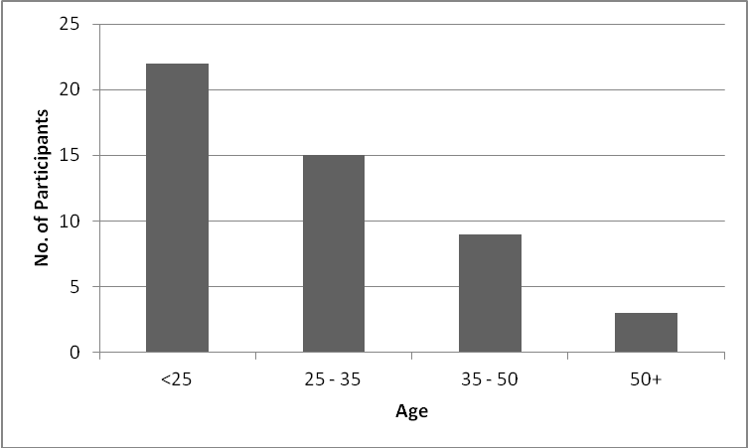
Figure 1: Survey 1 – Age distribution of participants.

These participants had varied occupations as well. A majority of the users were students, self employed, and work at homes. Other occupations present were from the technical, medical, commercial and art industries. This ensured we had a perspective from a diverse user base.

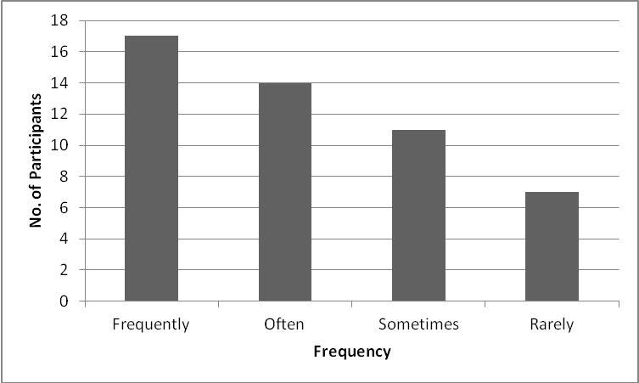
Figure 2: Survey 1 – Frequency of Facebook usage.

The distribution of the number of friends that the participants had was a wide range. This can be seen in fig 3.

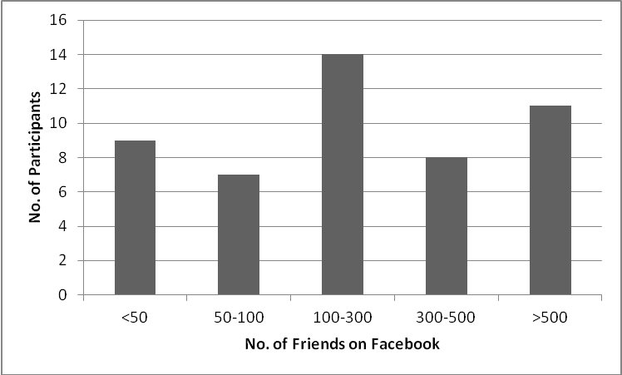
Figure 3: Survey 1 – Distribution of no. of Facebook friends.

Due to the size of our survey we have not captured a perfect subset of the real world. However, we believe these results to still be useful even though they are not perfect.

- Analysis of results:
We will now see and analyze the results of the survey. We will start by an analysis of the scope of the problem. See fig. 4 to get a better understanding of the amount of inappropriateness the users saw on Facebook. To get a better perspective we asked the survey participants "Do you agree or disagree that people post inappropriate personal information or embarrassing comments?"
We further analyzed these results and found that anyone who uses Facebook frequently or at least often, agree to some degree. Users who did not see inappropriate comments online were users who used Facebook sometimes or rarely.
We came to these results by performing associative rule learning. Which is a technique that is used to identify interesting relationships between variables in databases [22].
The exact results showed that 86% of frequent users strongly agreed and the remaining 14% partially agreed. This means if you use Facebook frequently you are bound to see inappropriate posts.

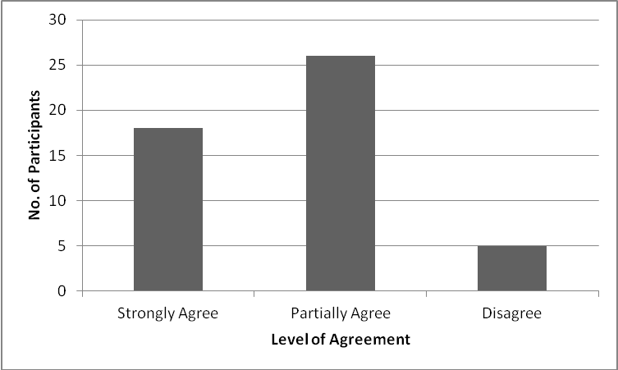
Figure 4: Survey 1 – Agreement to having seen inappropriate posts on Facebook.

We further tried to identify the types of inappropriate posts users saw. We based our question on results from a paper that identified regrets on a large scale [2]. We also provided an open ended option to further identify comments that were considered inappropriate. In fig. 5 we show the types of inappropriate comments seen by users.
As you can see from fig. 5 there were several responses to the open ended question. These replies were:
- Naive opinions
- Overly political comments
- Controversial views
- Complaints
- "Touchy feely comments"
- Bragging

Not all of these responses indicate inappropriate comments per se. This is what caused the inception of the idea for providing ratings to comments in our system. We hoped that comments that people disliked in general could be rated by them. If the comment received more negative than positive feedback it would mean that it is not liked, even if it is not inappropriate.

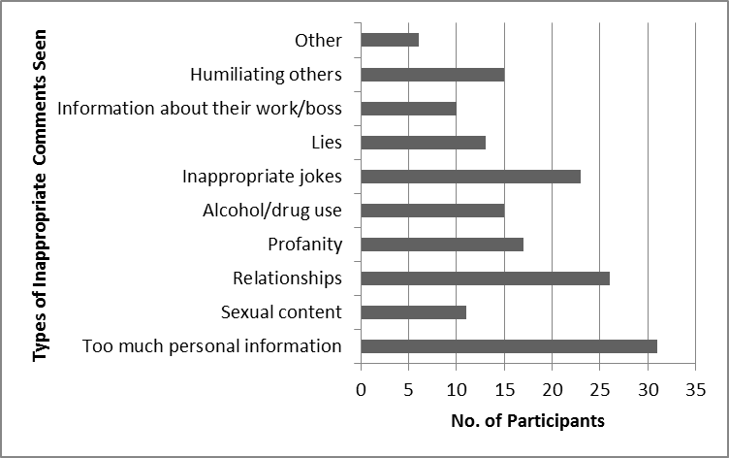
Figure 5: Survey 1 – Types of inappropriate comments seen on Facebook.

However, when asked if they responded to any of these inappropriate comments, a majority of users who saw inappropriate posts 32 out of 44 (73%) did not respond to any of these comments. Only 12 people (27%) responded to these comments.
Out of these 12 people, 5 (42%) of them did not provide any useful feedback about the comment. The remaining 7 (58%) did point out the inappropriateness or made suggestions on what the poster should do.
What we mean by not providing any useful feedback above, is comments that were making fun of the comments, abusive, or not really addressing the inappropriateness.
On further analyzing the result using our associative rule learning tool, we found that male participants were more likely to respond to inappropriate comments. Out of the 12 respondents, 8 of them were male. This large gender based bias could be explained through psychology literature. Men tend to be more assertive about their views in conversation while women tend to value cooperation [26]. So, in order to avoid conflict online women might not respond to such comments. This may possibly explain this gender based bias.
We then tried to get a better understanding of why people did not want to reply to inappropriate comments. On being asked why, the response we got was varied. See fig. 6 to get a better perspective.
Basically, people did not care about the post or person, or were too shy or did not know the person well enough. We hypothesize here that given anonymity, people who were too shy or did not know a person well enough should have no difficulty in providing feedback. This holds true only if they really want to help the person.
This question also contained an open ended response type from where we could determine other reasons for not replying to these comments. The options provided in the answers for these questions were based on an impromptu brain storming session. This of course meant that we would not gather all possible responses, but we did try to capture the ones that we felt were the most important.
The replies that we received in the open ended option mainly involved not wanting to get into arguments online, and not wanting the added "drama." Other responses included not wanting to waste their own time, and not meddling in other people's business.
We again believe that by providing a set bunch of responses, people were less likely to come up with their own reasons. This bias could have been avoided with providing only an open ended questions, but we feel that we received a good range of answers even in this format.

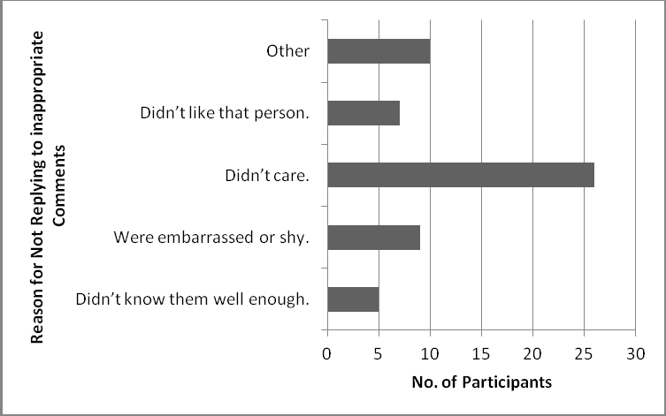
Figure 6: Survey 1 – Reasons for not replying to inappropriate comments.

We then suggested the usage of an anonymous comment posting system to the participants in the survey and asked them if they were now likely to respond. The number of people now likely to respond went up to 28 (57%). This was a significant improvement from the previous 12 respondents as well. The useful feedback went up from only 8 participants to 17 participants. That is, more than a 110% increase, which was promising in terms of the usefulness of an anonymity system. But, as we mentioned earlier, the quality of the posts actually went down as well. The number of non-useful comments went up from 5 participants to 11 participants. This is, an increase of 120%.
This goes to show that even though anonymity is a good tool in increasing amount of feedback, it is not always feedback we want. The increase in number of responses came at a cost. The cost was the quality of the content of the comments. The anonymous responses tended to be more abusive as well.
This part of the survey showed that anonymity does help in increasing the amount of responses made to an inappropriate comment. We wanted to see if people still took affirmative action based on feedback they received anonymously.
To test this, we asked in the survey if people would take any action based on anonymous comments. We found that 15 people (30%) would not take any action based on anonymous feedback, while the rest would take some action. This goes to show that people might not listen to anonymous comments. In fact one of the participants said “I wouldn’t want such a feature.” As we did not gather the baseline of listening to advise given to a person by their peers identified, we cannot come to any conclusion based on this piece of information.
An interesting relationship we found using our associative rule learning tool here was the men were less likely to take any action based on anonymous comments than women. Of the 15 participants unwilling to listen to anonymous comments 12 (80%) of them were men.
Another level of mining showed that all 12 of these men had also not responded to any inappropriate comments and the reason for not responding to these comments was not caring about it.
While no parallel could be found to this situation, we found that men are more likely to use impersonal information sources (articles, reports, etc) for information rather than personal sources (such as other people's inputs) [33]. With men not relying more in personal feedback, such a system may not benefit these men, at least in theory.

- Survey 2:
  - Demographics:
This survey had 41 participants after removing data that did not meet our requirements. These requirements were identical to the requirements of survey 1.
We got 21 male, and 20 female participants. This was a more realistic distribution of the genders than survey 1. The age of the participants was distributed from 21 to 76 years. This distribution was again more realistic as compared to the distribution from survey 1. This is because Facebook usage is shown to be more popular with middle age users than young users [21].

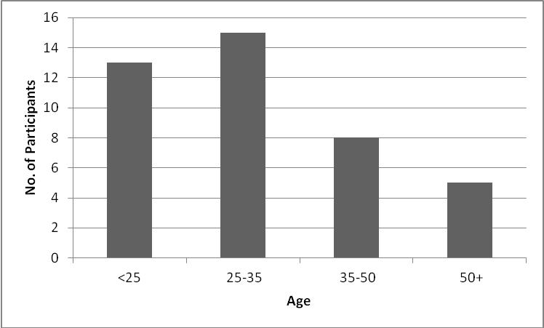
Figure 7: Survey 2 – Age distribution of participants.

However, the results we received were fewer in number hence we feel they might not be as representative of the actual population as the results of survey 1 due to the fact that the result list is more sparse.
The frequency of Facebook usage was well distributed in survey 2 as well. The distribution can be seen in fig. 8. The definitions of the terms describing the frequency of usage are the same as in survey 1.
This result is skewed more to the frequent users. This may result in showing that would show that users post more inappropriate comments than the general population would. However, we have not found any research on the relation between frequency of usage of social media and content of the posts made.

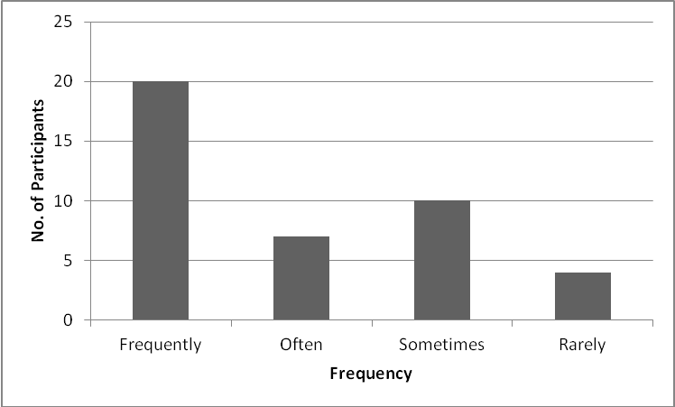
Figure 8: Survey 2 – Frequency of Facebook usage.

The distribution of the number of friends that the participants had was again a wide range. This can be seen in fig 9.

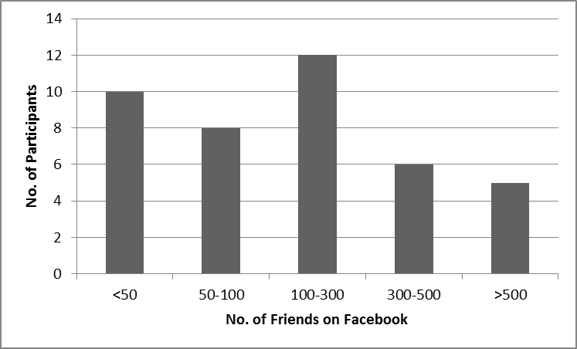
Figure 9: Survey 2 – Distribution of no. of Facebook friends.

  - Analysis of results:
This survey was more focused on identifying users' perception of their own inappropriate posts. We started by asking if the users have posted any inappropriate content. A majority had claimed not to have posted any inappropriate comment online, i.e. 24 of 41 participants (59%).
A minority, 17 of the 41 participants (41%) had posted something inappropriate. When asked how this group identified their inappropriate posts, it was found that a large number of these users, 12 of them (71%) realized there inappropriate post by themselves.
The minority that got feedback, received it mostly in the form of jokes or comment of a humorous nature (60%), harsh comments (20%), and actually pointing out their mistakes (20%).
The response to the comments was as follows. The feedback that actually pointed out the mistake in the post, was handled by explaining the post to the feedback provider. The harsh comment was ignored. The jokes on the inappropriate posts were participated in by 2 of the poster (67%), and taken down by the remaining user (33%).
The users were also asked if they would prefer getting help to identify inappropriate posts. Most of the participants preferred getting help (77%). The distribution of users who received help and the ones who did not receive help agreeing that feedback is useful is shown in Fig. 10.

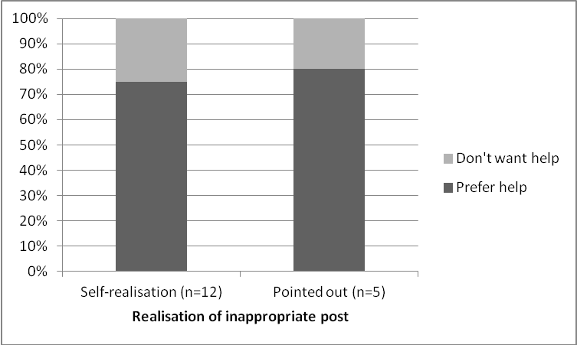
Figure 10: Participants feelings about receiving help to improve self-awareness.

See Figure 11 for a distribution of the types of inappropriate comments made, which were more focused on too much personal information (47%). . The "other" refers to a participant who received feedback asking for taking down a political comment.

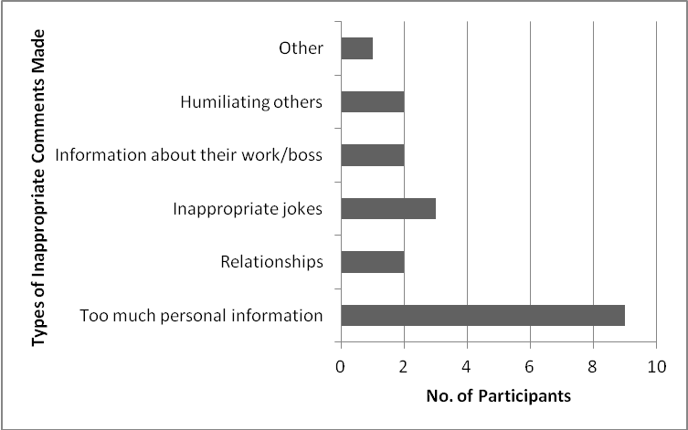
Figure 11: Types of inappropriate comments made.

The results for inappropriate behavior of participants is an even more sparse data set from an already small data set. This does mean that the data collected is probably not a true representation of the actual population.
On performing associative rule learning on this data, we found that frequent users were 80% likely to have posted inappropriate comments. And people with more than 100 friends were 87% likely to post inappropriate comments.
This goes to show that, if you are a frequent user of Facebook, you are not only more likely to see inappropriate posts, but also, make inappropriate posts yourself.
- Semi-structured Usability Study:
This study, as mentioned earlier, was semi-structured. We referred to a set question list and based on the response we got we modified our follow up questions.
The overall consensus regarding the system user interface was favorable. There were minor alignment issues and a couple of complaints that it increased the size of the page significantly while browsing. We would have liked to address the size issue by making the commenting system disappear till a user wants to use it but we felt this is a minor issue that could be addressed at a later date.
A majority (6 out of 10) of the participants would have like the system to allow open ended comments. The general feeling was that this tool would become more enjoyable to use. We agree that the tool will get wider acceptance and use in the market if it permits any comment to be posted. As the aim of this project is to improve user behavior by increasing awareness of inappropriate posts, and from the survey results we can see that anonymity actually increases the amount of inappropriate behavior, we find unrestricted comments counterproductive to the aims of our study.
The participants had mixed feelings about the star rating system for the posts. Answers included liking the system more than the drop down list and possible unrestricted comments, to not understanding the purpose of rating posts. The plus point for the rating system was that it did not involve doing much work other than selecting a rating. The negative points include ratings being too indirect, and confusing on the basis of the rating. One participant put the confusion faced into words well; he said “am I rating the content, the grammar, or the person?”
We had most users (8 out of 10) wanting to point out comments that they found annoying, these included selfies, pictures of food, and updates that they felt were unnecessary. We suggested that rating the comment with lower star ratings may have the same effect. This convinced most, but, a couple of users still insisted on an option for flagging annoying posts.
Another request for a comment was an insensitive flag. We have included this to our list of flags for comments. But as we already got a few complaints for the list being long, it is not in the best interest of usability to keep adding more and more element to the list.
Some of these users (4 out of 10) would be willing to help only their "true " friends. These users were less likely to take advice if it was not from one of these "true" friends as well. They were also more direct with the feedback they gave to their "true" friends, i.e. they would likely just tell their friends online, or inform them when they "hung-out" later.
This goes to show that some people are willing to help strangers, and others are not. We argue that some of these can provide a bulk of the feedback and hence balance out the users unwilling to help their acquaintances. However, on the unwillingness to accept feedback there is no silver bullet as yet. This means we can try with our best intention to help but people will still not listen.
This was a promising study. With a few alterations to this system, like a textbox for comments instead of a drop down list, the system would be very popular. This could be one way to increase user enrollment for the system.

- User Study:
The final study of our system was not quantitative but very qualitative. The selected participants posted inappropriate comments on Facebook, but to do so they used very different procedures. But both procedures required a lot of extra effort on part of the users.
The first participant was an Art graduate who was an advanced Facebook user. What we mean by an advanced user, is that he used features such as lists, private pages, and changed all privacy settings to meet certain conditions before posting. By following these rigorous routines, he frequently posted inappropriate comments. But as the audience of his posts was very targeted he did not get many complaints. However, he started using all these Facebook features only after being banned from Facebook for an inappropriate comment.
He was very unapologetic of his posts, and his friends did not complain about his posts. Even when they did, he relished getting into online arguments. If these arguments were not private, he removed them whenever he applied for a new job. His posts generally contained a lot of profanity.
He also saw a lot of inappropriate posts, and replied to the poster directly whenever possible. When he was given the tool, he "loved" the idea of being able to rate posts, and anonymously judge them. He requested us to make this system allow anonymous comments, so he could "troll" his friends.
However, when shown comments that were added to his posts by a black box i.e. by us without of course him being aware of this fact, he looked at each of the posts that were marked and did not really take any action. He said that this would make him pay attention to the posts that were flagged but he would not take any action until he felt it was necessary.
The second participant was a Computer Science student. His approach to posting comments was very different. He maintained pseudonymous Facebook accounts. The one he shared for the study was one that contained very personal opinions on different subject matters. Political and religious opinions were very prevalent.
He did not employ any other features from Facebook for maintaining group distinction. However, he maintained only 20 friends on the Facebook page.
When provided with an anonymity tool, he said, as he maintained different pseudonyms, anonymity would not be as useful to him. He would have preferred to have different groups to be able to identify it was him. He liked the feature allowing him to get feedback.
He was very responsive to the feedback he received from our "black box". He said he never thought of the posts in such a way and even took down a couple of the flagged posts.
This study did not get actual lay user participation. This can be attributed to our recruitment flier that asked for users who have posted inappropriate posts. However, we got to see two extreme types of users, one was open to anonymity, the other was receptive to feedback and would have preferred pseudonymity.

System
Our system was designed as a Google Chrome extension. It is meant to target Facebook users who are also Chrome users. The greatest issue we faced with the implementation of our system was the instability of the Facebook Document Object Model (DOM). Regular changes led to continuous re-implementations of our system. It also resulted in data loss from our study on a regular basis. During the course of the project we have modified the code a total of 7 times to match the DOM changes made by Facebook.
To tackle this problem we had to develop an additional compiler that keeps track of the DOM changes in Facebook. This compiler while not perfect did churn out better results. To ensure that the amount of change made by Facebook is more in perspective, we should point out that we have two major versions of our source code. One version uses Java Script and the other JQuery. This does not include the many minor version changes in our source code. Our compiler has made the changes to our source code a total of 3 more times than our above mentioned manual changes.

- Interface
Our system was designed to closely mimic the commenting system on Facebook. It is currently viewed as just a 5 star rating system, and an additional drop-down box and button under each item on their timeline.
Once our system is added to the Google Chrome browser, usage of Facebook will reveal our user interface (UI). The UI consists of a drop-down list, which contains a limited list of flags for a comment. These flags are based on prior work on online regrets [2]. These findings were validated by our survey as well.
The reason for providing a drop down list instead of an unrestricted text box was that a vast majority of anonymous users intended to use the tool for posting inappropriate comments themselves. This was shown in the survey results as well as the study. Hence, to tackle this problem we allowed users to flag posts as one of the categories provided.
Once a post is flagged as inappropriate, that flag is made visible to anyone who has our extension installed.
We have also implemented a feature to rate the interestingness of a post. This rating system will tend to be very subjective, but our studies showed that people tend to dislike mundane posts and would have liked a tool to help them express this feeling. This feature, though not related to inappropriateness will allow an interestingness measure. This in itself is a useful feature according to us.
It allows more variations than just the like button. Instead of putting only a dislike button, which would have been the opposite of a like, we felt this allowed users to point out even banal posts. This is in a way to counter balance, the users need to point out posts that they find annoying, without actually putting it into words. Star ratings, have been shown to impact user behavior [28] as well making it a good choice for our system.

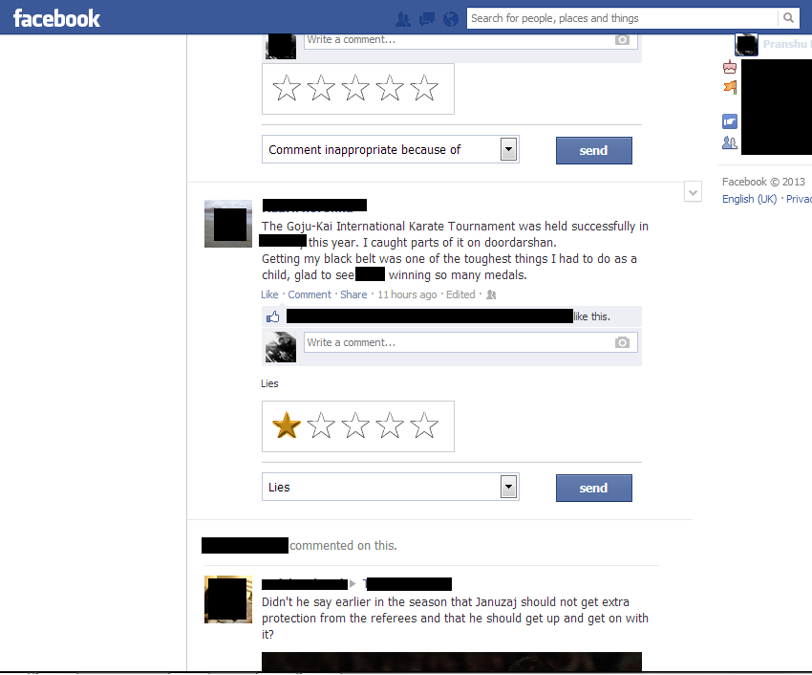
Figure 12: Screenshot of the system's User Interface while browsing the newsfeed

The system works both on the newsfeed, as well as the timeline. This is an important point to be made as both pages have very different structures, and are hence handled differently. In fig. 12 we can see our system UI Link with the Facebook newsfeed, and in fig. 13 we can see our system UI Link with the Facebook timeline.
The importance of the timeline is that a user can specifically target a person he knows who has posted inappropriate comments.
The system had been made to look consistent over the many different page types in Facebook. This was a particularly difficult task as each type of page has a different DOM structure. With each type of page being modified at different times during the project, keeping the system UI working on all the different page types was nearly impossible. That is why our system implementation then focused on just the newsfeed and timeline.
If the users want to check to see if any comments have been made about their own posts, it is easier to see it on their own timeline. As there is no notification feature implemented as yet, this is the easiest way to check if any feedback has been provided on any of your posts.
We intend on overcoming this shortcoming in our future work by providing a dashboard.
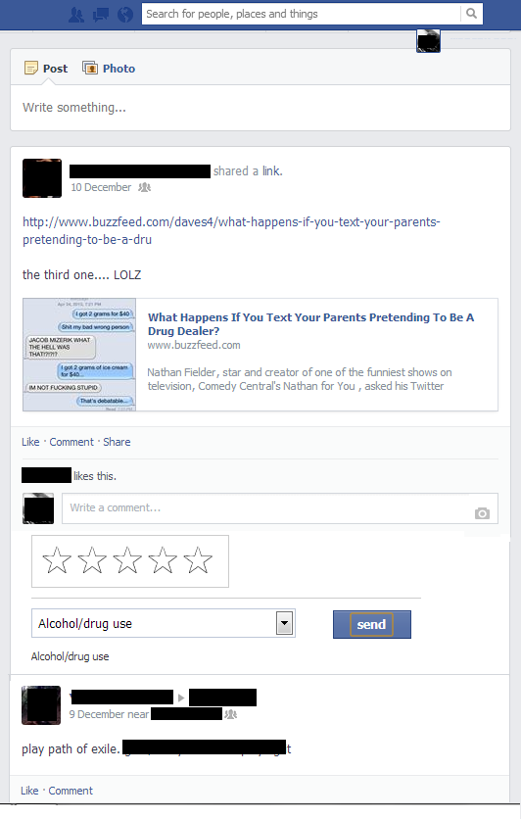
Figure 13: Screenshot of the system's User Interface while browsing a timeline.

- Architecture
The system front-end is the Google Chrome extension which we mentioned above in the design section. It connects to our MySQL server back-end. It is from the back-end that we add and retrieve our anonymous feedback to posts. The connection is done using PHP as our middleware.
In the following paragraphs, we will introduce the architecture of our system including our database, connections and user interactions.

- System Workflow
In this part, we give a brief example explaining how our system functions.
Suppose Bob is the user who posts some inappropriate comments. Bob’s friend Alice wants to provide feedback or make some suggestions to Bob.
Before we can start though, we require all participants to use Google Chrome on a desktop while using Facebook and to install our extension. The system then works as follows:
- Bob posts some inappropriate comments
- Alice sees the post and chooses to comment anonymously.
- Alice’s comment is sent to our database
- The comment is dynamically retrieved from our database and displayed under the post in all pages (newsfeeds, and timelines) where the post is visible, while using our extension. Carol, who is also a friend of Bob, who is also using our extension; can also see the anonymous comment has been made.
- Once Bob returns to his own Facebook page, these comments will automatically be shown under his own post. Since we do not show who comments and we don’t even store this information in our database, we provide anonymity to the user.

- System Connectivity
Our system connects from a Google Chrome browser extension to store all the anonymous comments in our database. We use Ajax to send data to the database and use PHP to deal with the data sent from our system and return the data with JSON format if the system requires the data.

- System Backend
The basic format for storing each comment is showed in the following tables:

Visible | Comment | Post_id
0 | Too much personal information | 9182739182379120
Table 1: Database content

Where,
“Visible” represents whether the comments are available to the public or just the original poster. 0 means it is available to the public and 1 means only the poster can see the comment. For now our system sets this value by default as 0.
“Comment” represents the content of a specific anonymous comment.
“Post_id” represents the unique id of that Facebook user to identify a post.

However, based on the usability study, we added some more attributes to our database to provide a more user-friendly service. The following columns have been appended to the table.

Time | Rating | Name | Peer_acceptance_ percent
2013-12-11 10:09:08 | 4.0 | John Doe | -
Table 2: Database content (contd.)

Where,

“Time” represents the time at which the anonymous comments were made. The order of comments will be displayed based on time sequence chronologically. We had implemented this feature and soon realized by knowing what time a post was made it would increase the ease with which a person may guess who made the post. So, we do not display the time of the comment, and only use it to maintain an order or sequence of the anonymous comments.
“Rating” is represents a feature which allows users to rate comments on a scale of 5. Where 1 is least liked by the rater & 5 is extensively liked. This is a different take on the Facebook thumbs-up and is more along the lines of the rating system that YouTube used to follow in its heydays. This is not to specifically point out any inappropriate comment.
“Name” represents the person who receives anonymous comments and this attribute is used to combine another table for a statistical feature.
“Peer_acceptance_percent” represents what percentages of people agree with the comments made by the anonymous commenter. This is not implemented in the current version of our system. But as unrestricted comments are one of the most requested features in the user studies, we hope to implement it in our future work.

- Implementation
To run the code, one needs to install Google Chrome and then load the extension. We have uploaded a link to the extension in appendix D.

- System Shortcomings & Possible Solutions
The purpose of this section is to identify the flaws in our system and try and provide remedies to them. We would have liked to implement these solutions into our system but due to time constraints we have to limit ourselves to merely describing the problem and mentioning the possible solution thereof.
As we have mentioned in the results section, we received a couple of complaints that our system was increasing the size of the page significantly. To address this issue we intend to make the system hide our added features till a user requires it.
A problem with the above is that we only retrieve data once the users can see their own posts. If the posts have become stale and are no longer visible on their page, then the poster will not get the feedback. To solve this problem we are working on a dashboard whose primary purpose is to inform users if any comment has been made on their post. We also intend to make this keep track of comments received on a weekly/monthly basis to give the users a better understanding of the activities.
This problem will however not be significant if the response time to a post is negligible. However, a response when a user is online at the same time as a person giving an anonymous comment, leads to a possible failure in our anonymity guarantee.
A flaw in our anonymity guarantee can be explained in the following example: basically if Alice anonymously posts a comment while Bob is online, and Alice is the only person online at the moment on Bob’s friend list, then Bob may easily be able to conclude with high probability that it was Alice that made the anonymous comment.
The severity of the anonymity guarantee problem may be alleviated as Facebook chat is used to keep track of who is available online, and if a person may keep himself hidden at a given time, then this problem can be avoided. In fact, the presence of the feature allowing users to hide themselves while online leads to never really being able to tell with surety if a person is online.
With the availability of the chat feature on mobile devices, people appear to be online for the entire duration of the day & night as well. This goes on to further assuage the flaw in anonymity guarantees.
A possible solution to the problem is to hold an anonymous comment for a random medium-long (a few minutes to a few hours) duration before allowing it to be published. This solution causes the first problem of a post being buried under a lot more content before a user can view it.
The problem of anonymity loss will become more prevalent if users are allowed to send their own comments instead of using the set comments currently permitted. Language patterns have been shown to be increasing powerful at identifying users [23]. Preventing such attacks on anonymity requires the comment provider to follow basic obfuscation techniques [24]. The solution to this problem is beyond the scope of this paper.
All these problems are prevalent even before we get to mathematical guarantees of anonymity. An eavesdropper looking at network traffic from a system will still be able to monitor the transmission of data. Currently due to the non-implementation of Transport Layer Security (TLS) to transmit the data, the data is still visible to anyone packet sniffing.
To solve the problems of the lack of actual anonymity guarantee, we recommend using tools such as a Tor proxy while using our system to improve the anonymity guarantee.
We would like to point out here that the anonymity we guarantee is for regular (non-hacker) users who do not want to be identified by their regular friends. While we may try to provide better anonymity through proven security constructs, the current scope of this system is to allow users to provide better feedback. If this system is ever to be used by political dissidents in oppressive regimes, we may try and provide anonymity through security.
The biggest problem faced by the system is one well beyond the control of the creators of this system. This refers to the problem of Facebook modifying its DOM on a regular basis. As we have mentioned before, we have created a compiler that tries to keep track of the changes Facebook makes to its DOM. However, the capabilities of this complier are severely limited and require hours of human intervention at times to get the system restarted.
The only foreseeable solution to this problem is implement this system at the same level as the proprietary Facebook code as an internal system. This is out of the current scope of the creators of the system as well.

Conclusion and Future Work
We designed a system for users to get a better feedback anonymously on their online posts on Facebook. This system, based on the results from our surveys was modeled to limit the number of comments available to the users.
The system developed is a Google Chrome extension. However, the complex nature of allowing comments to be made on a large scale involves recruiting large groups of users, who are friends with each other participating. The dearth of time has prevented us from conducting a quantitative field trial of this system.
We found that our system would not be used by everyone to try and help their Facebook friends. However, a small number of users (12%) were willing to help others. We believe, as this subset of friends will be present in most friends' lists, there should be no problem in receiving anonymous feedback while using our system.
However, even after receiving feedback, users may not be willing to take action. Making users aware about their inappropriate posts is an important component of our feedback system to help them overcome online disinhibition [29].
People posting too much information is the largest problem faced by many Facebook users as shown in our survey results. This is a privacy risk. Without feedback most users relied on their own judgment to identify if a post is inappropriate, this is also shown in our survey results. With feedback we argue that the users will have a better understanding if their post has any fault.
We have already mentioned some of our future work based on certain system shortcomings. This includes adding a dashboard to our mechanism to allow a report to be available to the user, allowing him to see the number of anonymous comments he has received and statistics on what they are based on. We believe by allowing users to visualize what is being said about their comments, it will enable them to put everything in the proper perspective.
For improving our system design we wanted to conduct an additional survey to study the correlation between the way comments are framed and their impact on users' behavior. Currently, we are only allowing users to flag the comments. We have comments in place, but as we did not test them, we have not incorporated them in the system.
We would like to have tested the effectiveness of images conveying the essence of these comments as well.
Another limitation that we might address instead, is the one that is restricting our users to post only comments selected from a drop box. This was done to limit aberrant behavior when given anonymity. However, we understand the need to be able to send all types of comments as feedback. To tackle this problem we plan on peer reviews before posting them. These peer reviews may contain statistics of how many people agreed or disagreed with the comment.
Having moderators for comments in anonymous communications online is the best practice in many asynchronous conversation communities. These moderators will be able to keep the posts appropriate as long as a small minority of users agree to moderate and are vested in the online Facebook community [18].
On implementing moderated comments, we consider adding comment threading. That is the ability to view comments grouped in a hierarchy to allow users to see how a conversation is progressing.
We plan to continue collecting participants' ideas to improve our system as well. We also plan to conduct a large scale qualitative field study to test the efficacy of our system. We hope by getting more in-depth and long-term data we can study the effects of our system on users' behavior.
Privacy online is eroding, thanks to the abundance of information made available by people willingly sharing information. Inappropriate posts online result in actual harm in the real world, like in the case of a person being fired for making disparaging comments about his employer [35]. We have shown, by making privacy information salient to users, they will be more conscious about what they have shared. The effect on users in the long run is still something that needs to be tested. But the immediate effects have been promising.

Acknowledgments
We would like to thank our professors Dr. Lorrie Cranor and Dr. Norman Sadeh for their regular inputs, which guided us throughout the project. We would like to thank Manya Sleeper as well for providing invaluable support, feedback, and providing procedures for conducting our studies.
We received funding from Dr. Norman's Information Security and Privacy Class Funds.
Last but not least we would like to thank our fellow members from Carnegie Mellon University for willingly participating in our studies.

References
[1] N. B. Ellison, C. Steinfield, C. Lampe, "The Benefits of Facebook “Friends:” Social Capital and College Students’ Use of Online Social Network Sites," Journal of Computer-Mediated Communication, 12: 1143–1168, 2007. doi: 10.1111/j.1083-6101.2007.00367.x
[2] Yang Wang, Gregory Norcie, Saranga Komanduri, Alessandro Acquisti, Pedro Giovanni Leon, Lorrie Faith Cranor, "I regretted the minute I pressed share": a qualitative study of regrets on Facebook. Proceedings of the Seventh Symposium on Usable Privacy and Security (SOUPS '11). ACM, New York, NY, USA, , Article 10 , 16 pages, 2011. DOI=10.1145/2078827.2078841 http://doi.acm.org/10.1145/2078827.2078841
[3] Manya Sleeper, Justin Cranshaw, Patrick Gage Kelley, Blase Ur, Alessandro Acquisti, Lorrie Faith Cranor, Norman Sadeh. ""I read my Twitter the next morning and was astonished": A conversational perspective on Twitter regrets." Proceedings of the SIGCHI Conference on Human Factors in Computing Systems (CHI '13). ACM, New York, NY, USA, 3277-3286, 2013. DOI=10.1145/2470654.2466448 http://doi.acm.org/10.1145/2470654.2466448
[4] Yang Wang, Pedro Giovanni Leon, Kevin Scott, Xiaoxuan Chen, Alessandro Acquisti, Lorrie Faith Cranor, "Privacy nudges for social media: an exploratory Facebook study," Proceedings of the 22nd international conference on World Wide Web companion (WWW '13 Companion). International World Wide Web Conferences Steering Committee, Republic and Canton of Geneva, Switzerland, 763-770, 2013.
[5] Paul André, Michael Bernstein, Kurt Luther, "Who gives a tweet?: Evaluating microblog content value." Proceedings of the ACM 2012 conference on Computer Supported Cooperative Work (CSCW '12). ACM, New York, NY, USA, 471-474, 2012. DOI=10.1145/2145204.2145277 http://doi.acm.org/10.1145/2145204.2145277
[6] Lee Rainie, Aaron Smith, Maeve Duggan, "Coming and Going on Facebook," Pew Internet & American Life Project, February 5, 2013. http://pewinternet.org/~/media//Files/Reports/2013/PIP_Coming_and_going_on_facebook.pdf
[7] Cooper Smith, "7 Statistics About Facebook Users That Reveal Why It's Such A Powerful Marketing Platform," Business Insider, Nov. 16, 2013. http://www.businessinsider.com/a-primer-on-facebook-demographics-2013-10
[8] Manya Sleeper, Rebecca Balebako, Sauvik Das, Amber Lynn McConahy, Jason Wiese, Lorrie Faith Cranor, "The Post that Wasn’t: Exploring Self-Censorship on Facebook"
[9] A. Narayanan, V. Shmatikov, "De-anonymizing Social Networks," Security and Privacy, 2009 30th IEEE Symposium on , vol., no., pp.173,187, 17-20 May 2009
doi: 10.1109/SP.2009.22
[10] A. D. Madden, "Comment When did peer review become anonymous?", Aslib Proceedings, Vol. 52 Iss: 8, pp.273 - 276, 2000.
[11] I. Kagan, R. Kigli-Shemesh, N. Tabak, "'Let me tell you what I really think about you’– evaluating nursing managers using anonymous staff feedback." Journal of Nursing Management, 14: 356–365, 2006. doi: 10.1111/j.1365-2934.2006.00575.x
[12] Ruiling Lu, Linda Bol, "A Comparison of Anonymous Versus Identifiable e-Peer Review on College Student Writing Performance and the Extent of Critical Feedback”
[13] S. Milgram, “Behavioral Study of Obedience,” Journal of Abnormal and Social Psychology, 2007.
[14] P. Zimbardo et al, “Stanford Prison Experiments on Obedience: A Simulation Study of the Psychology of Imprisonment Conducted," Stanford University, 1971.
[15] Herman Aguinis, Ryan K. Gottfredson, Harry Joo, "Delivering effective performance feedback: The strengths-based approach," Business Horizons, Volume 55, Issue 2, March–April 2012, Pages 105-111, ISSN 0007-6813, http://dx.doi.org/10.1016/j.bushor.2011.10.004.
[16] R. H. Thaler, C. R. Sunstein. "Libertarian paternalism."
[17] Ruogu Kang, Stephanie Brown, Sara Kiesle "Why Do People Seek Anonymity on the Internet? Informing Policy and Design"
[18] R. E. Kraut, P. Resnick, S. Kiesler, Y. Ren, Y. Chen, M. Burke, N. Kittur, J. Riedl, J. Konstan, "Building Successful Online Communities: Evidence-Based Social Design," Cambridge, MA, 2012. http://kraut.hciresearch.org/sites/kraut.hciresearch.org/files/articles/Resnick10-Intro-current.pdf
[19] Rajiv C. Shah, Jay P. Kesan "Setting Online Policy With Software Defaults," Information, Communication & Society, Vol. 11, Iss. 7, 2008.
[20] “Facebook Help: Desktop”, Facebook http://www.facebook.com/help/www/
[21] Pingdom "Report: Social network demographics in 2012," Tech blog, August 21st, 2012. http://royal.pingdom.com/2012/08/21/report-social-network-demographics-in-2012/
[22] Gregory Piatetsky-Shapiro, William J Frawley, "Discovery, analysis, and presentation of strong rules," Knowledge Discovery in Databases, AAAI/MIT Press, Cambridge, MA. 1991.
[23] Rong Zheng, Jiexun Li, Hsinchun Chen, Zan Huang “A Framework for Authorship Identiﬁcation of Online Messages: Writing-Style Features and Classiﬁcation Techniques” http://cci.drexel.edu/faculty/jli/docs/Jounals/Zheng_2006JASIST_AuthorshipIdentification.pdf
[24] Michael Robert Brennan, Rachel Greenstadt “Practical Attacks against Authorship Recognition Techniques” AAAI Publications, Twenty-First IAAI Conference http://www.aaai.org/ocs/index.php/IAAI/IAAI09/paper/view/257
[25] W. Keith Campbell, Constantine Sedikides, Glenn D. Reeder, Andrew J. Elliot, "Among friends? An examination of friendship and the self-serving bias." British Journal of Social Psychology 39 (2): 229–239, 2000. doi:10.1348/014466600164444.
[26] E. Sharon Mason, “Gender Differences in Job Satisfaction,” The Journal of Social Psychology Vol. 135, Iss. 2, 1995.
[27] R. Agrawal, T. Imieliński, A. Swami, "Mining association rules between sets of items in large databases". Proceedings of the 1993 ACM SIGMOD international conference on Management of data - SIGMOD '93. p. 207. 1993. doi:10.1145/170035.170072
[28] Dan Cosley, Shyong K. Lam, Istvan Albert, Joseph A. Konstan, and John Riedl. "Is seeing believing?: How recommender system interfaces affect users' opinions," Proceedings of the SIGCHI Conference on Human Factors in Computing Systems (CHI '03). ACM, New York, NY, USA, 585-592. DOI=10.1145/642611.642713 http://doi.acm.org/10.1145/642611.642713
[29] John Suler, "The Online Disinhibition Effect", The Psychology of Cyberspace, Aug 04 http://truecenterpublishing.com/psycyber/disinhibit.html
[30] James C. McCroskey, " Oral Communication Apprehension: A Summary of Recent Theory and Research" Human Communication Research, 4, 1, 78-96, F 77, 1977. http://onlinelibrary.wiley.com/doi/10.1111/j.1468-2958.1977.tb00599.x/pdf
[31] Mary Madden, "Privacy management on social media sites" Pew Internet & American Life Project, Feb 24, 2012 http://www.pewinternet.org/Reports/2012/Privacy-management-on-social-media.aspx
[32] Alice H. Eagly, Maureen Crowley, "Gender and helping behavior: A meta-analytic review of the social psychological literature." Psychological Bulletin, Vol 100(3), Nov 1986, 283-308. doi: 10.1037/0033-2909.100.3.283
[33] Nelson Barber, Tim Dodd, Natalia Kolyesnikova, "Gender differences in information search: implications for retailing", Journal of Consumer Marketing, Vol. 26 Iss: 6, pp.415 - 426, 2009.
[34] Sandra Speer, "Peer Evaluation and its Blurred Boundaries: Results from a Meta-evaluation in Initial Vocational Education and Training." Evaluation 16.4 (2010): 413-430.
[35] Dan Majors, "Out at the plate: Pirates dump outspoken pierogi," Pittsburgh Post-Gazette, June, 19, 2010.

Appendix

A. Survey Forms

Survey 1
1) How often do you use Facebook?
Regularly(more than once daily)
Often (once every day)
Sometimes (a few times a week)
Rarely (a few times a month)
Never

2) Do you agree or disagree that people post inappropriate personal information or embarrassing comments?
Strongly Agree
Partially Agree
Disagree

3) If you agreed in question 2:
Was the comment about any of these: [Check all that apply]
Too much personal information
Sexual content
Relationship information
Profanity
Alcohol/drug use
Inappropriate jokes
Lies
Information about their work/boss
Humiliating others
Other (Please Specify)

4) Could you give an example of some of these comments? (Look at your timeline if you want)

5) Have you ever responded to any of these comments?
Yes
No

6) If you said Yes in question 5:
What type of reply did you make?
Pointed out their mistake.
Made suggestions on what they should do.
Made a joke about it.
Other (Please Specify)

7) What did your reply say (Look at your timeline if you want)?

8) If you said No in question 5:
Why didn't you say anything?
Didn’t know them well enough.
Were embarrassed or shy.
Didn’t care.
Didn’t like that person.
Other (Please Specify)

9) If you were provided a tool to anonymously post comments to people regarding their posts, what would you say to them?

10) Would you take action if there was an anonymous comment posted by your friend telling you that you posted/shared something inappropriate/ personal?
Yes (Take the post down/Ask your friends if anything is wrong/Apologize)
No
Depends (Please Specify)

11) What's your gender?
Male
Female

12) What's your age?

13) What's your occupation?

14) How many friends do you have on Facebook?

Survey 2
1) How often do you use Facebook?
Regularly(more than once daily)
Often (once every day)
Sometimes (a few times a week)
Rarely (a few times a month)
Never

2) Have you ever posted anything on Facebook that you have come to regret later?
Yes
No

3) What did your post contain?
Too much personal information
Sexual content
Relationship information
Profanity
Alcohol/drug use
Inappropriate jokes
Lies
Information about their work/boss
Humiliating others
Other (Please Specify)

4) How did you come to regret the post?
Self realization
By others pointing it out

5) Do you think someone telling you about the post increasing your awareness about the regret would have helped?
Yes
No

6) What type of reply did they make?
Pointed out the mistake.
Made suggestions on what you should do.
Made a joke about it.
Other (Please Specify)

7) How did you handle the situation?
Take the post down
Keep the post, ignore the comment
Explain your post
Ask your friends if anything was wrong
Apologize
Other (Please Specify)

Please fill this demographic information

8) What's your gender?
Male
Female

9) What's your age?

10)
How many friends do you have on Facebook?

B. Think Aloud Study: Instructions, Tasks, and Questions

Introduce Myself.
"Hello, my name is <Chao/Pranshu>, and I am conducting a study that looks at how people use an anonymity tool we have created for Facebook. Are you a Facebook user? <if, "yes"> Do you mind if I/we talk with you for a few minutes?"
Sit Down
"If you have fifteen minutes to spare and are willing to allow me to observe you while you interact with this extension for Facebook I/we have on this laptop. Are you interested?"
Screen them for Facebook knowledge
"Before we begin, I have a couple of question to ask you about how familiar you are with using Facebook, so I can get a better idea of the type of user you are:
- How often do you use Facebook?
- How often do you post on Facebook, on average?
- Do you use private messages, chats on a frequent basis?
- Have you ever posted something you regret on Facebook? <if "yes" probe for more information about what was posted and how it was handled>
- Have you seen offensive/inappropriate posts on Facebook? <if "yes" probe for more information about what was posted and how they handled it>"
Study instructions
"The point of this study is to discover if people can get thoughts they want to get across conveniently on Facebook anonymously. I'm going to ask you to go through your Facebook posts and perform some tasks on this laptop. Facebook can be accessed through Google Chrome, and our software interface just lies on top of it. I'm testing the software not you. I'm looking for place where our software may be difficult to use or have some shortcomings. So if you don't manage to do some things do not feel bad. That is exactly what we are looking for. Remember, this is completely voluntary. Although I don't know why this might happen, but if you become uncomfortable in any way feel free to stop. In this observation, I am interested in what you think about as you perform the tasks I'll be asking you to do. I'm going to ask you to 'think aloud' while you are using the software. What I mean by think aloud is that I want you to tell me EVERYTHING that you are thinking about from when you see the task till you finish. I would like you to talk aloud CONSTANTLY from the time that I give you the task till you complete it. I don't want you to plan out what you say or try to explain to me what you are saying. Just act as if you are alone speaking to yourself, only a little louder."
Instruct them on how to think aloud: mundane task
"Let me demonstrate thinking aloud for you as I try to multiply 42 x 36 in my head.
<Illustrate thinking aloud>.
Now, you try thinking aloud, 'How many windows are there in your house?'
Good!"
Instruct them on how to think aloud: disabling the screensaver
"Now, those problems were solved inside our heads. However, when you are working on the computer, you'll also be looking for things, and seeing things that catch your attention. These things you are searching for and things that you see are as important for our observation as thoughts you are thinking from your memory, so please speak those out as well. For example, listen to the types of things I say while I disable the screen saver.
<Illustrate thinking aloud>
Now it's your turn to think aloud as you are using the computer. Please think aloud as you change the background.
Great! I'm going to give you some final instructions now."
Final Instructions
"As you're doing the task I won't be able to answer any question. But if you do have any questions, go ahead and ask them anyway so that I can learn more about what kind of questions the software brings up. I'll answer your questions after the session. Also, if you forget to think aloud, I'll say, 'Please keep talking.' Do you have any questions about thinking aloud? Now I have some tasks printed out for you."
Hand them the task and ask if you have any questions
"Here is the tasks you will be working on. Why don't you read it aloud, just so you can get comfortable with speaking your thoughts. Do you have any questions about the task?"
Tell them they may begin
"You may begin"

List of Tasks, Questions
Perform the following tasks:
- Start Google Chrome.
- Press Ctrl + Shift + n to start an incognito window.
- Go to www.facebook.com
- Log into your Facebook account.
- Do you notice any difference?
- How do you like the interface? [Ask for explanation of what the interface is for]
- Go through your own timeline.
- Locate a post you find offensive/inappropriate/un-needed.
- Try using our anonymous comment software to convey your thoughts. (This won't be linked to you later, and only people with this software can see the comment, so as of now only people using this controlled computer).
- Explain if you were able to do what you wanted to with our software.

- What would you have liked different in the software?
- Do you like the dropdown list or the rating system? Why?
- Do you feel we should add something more to the dropdown list?
- Would you listen to feedback you received from such a system?
- Do you think this system is useful?
- Any more suggestion?

C. Study Recruitment Advertisement
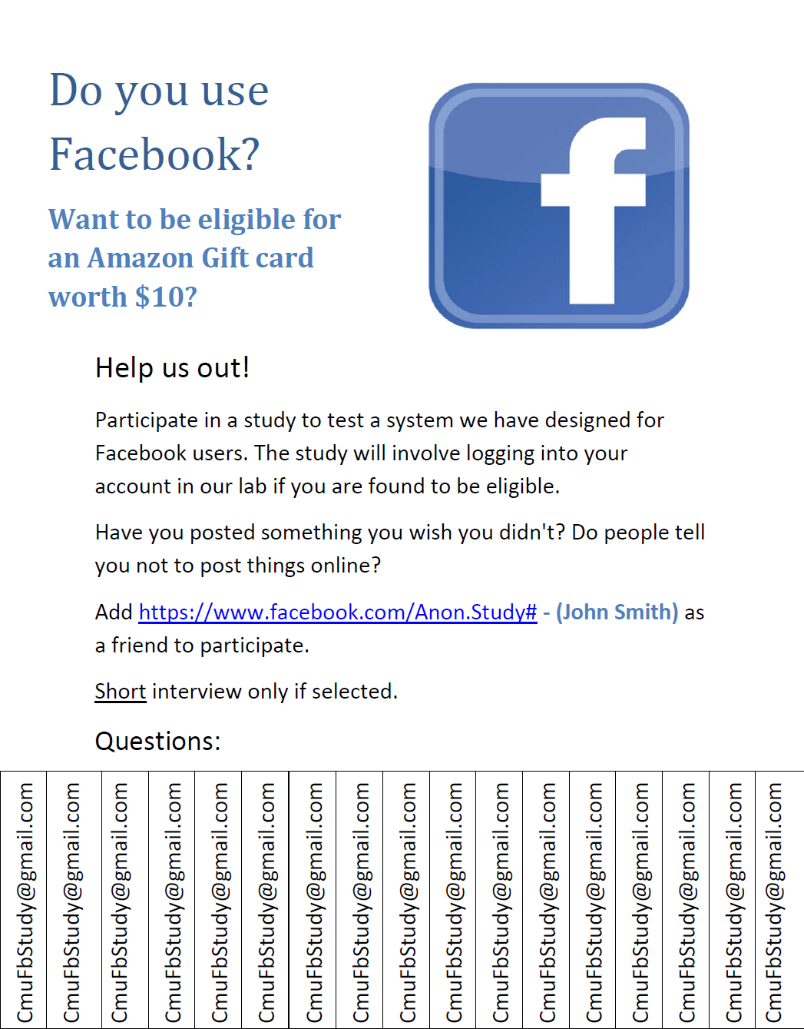

D) Google Chrome Extension

The following link contains a downloadable version of our system:
https://drive.google.com/file/d/0B2ni-8KyTTICMjNpdHZKRjZYNXM/edit?usp=sharing
It was fully operational as of December 14, 2013.

